Practical NO1::------------------------------------------------------------------------------------------------------------------

<html><head>

<title>registration FORM</title>

<style>

form {border:orange; border-width:2px;padding:10px; border-style:solid;}

body {padding: 0px 200px 0px 200px;}

</style></head>

<body>

<FORM action="PAYMENT HTML"><center>

<legend style="color:blue;"><b> <i>Genral Information</i></b></legend></center>

<p><b>First name: </b><input type="text" placeholder="Mahatma"required >&nbsp&nbsp&nbsp

<b> Last name: </b> <input type="text" placeholder="Ghandhi" required></p>

<table>

<p> <b> Email*:</b> <td><IMG SRC="http://pngimg.com/uploads/email/email_PNG11.png" HEIGHT="20PX" WIDTH="30PX" ></i></h4></td>

<td><input type="email" placeholder="your@gamil.com " required><br>

<td><b>Enter Password&nbsp&nbsp<b></td>

<td><IMG SRC="https://upload.wikimedia.org/wikipedia/commons/thumb/e/e1/Password.svg/1024px-Password.svg.png" HEIGHT="25PX" WIDTH="25PX"></td>

<td><input type="password" value="Enter Password"><br></td>

</table>

<p><b>Mobile no.</b> <input type="number"placeholder="123456789" required >

</p><b> Age</b> <input type="number" placeholder="enter your Age" required ><p >

<p><b>Permanant Address:</b><br><textarea required cols="50">Enter your address required</textarea></p> <p>

<p> <b> State:</b> <input type="text" name="state" placeholder="Maharashtra" required>

<p><b> Did you have any Disability</b> <input type="radio" name="section"> Yes <input type="radio" name="section>No<p>

<p><b> Date</b> <input type "Date"> <p>

<p><b> Gender <b>

<input type="radio"name="r2"> Male <input type="radio" name="r2">Female <input

type ="radio"name="r2"> Other</p>

<Button id="sl1">Submit</button>

<input type="Reset" id="sl"></input></form>

</Body>

</html>

Output::=============================================

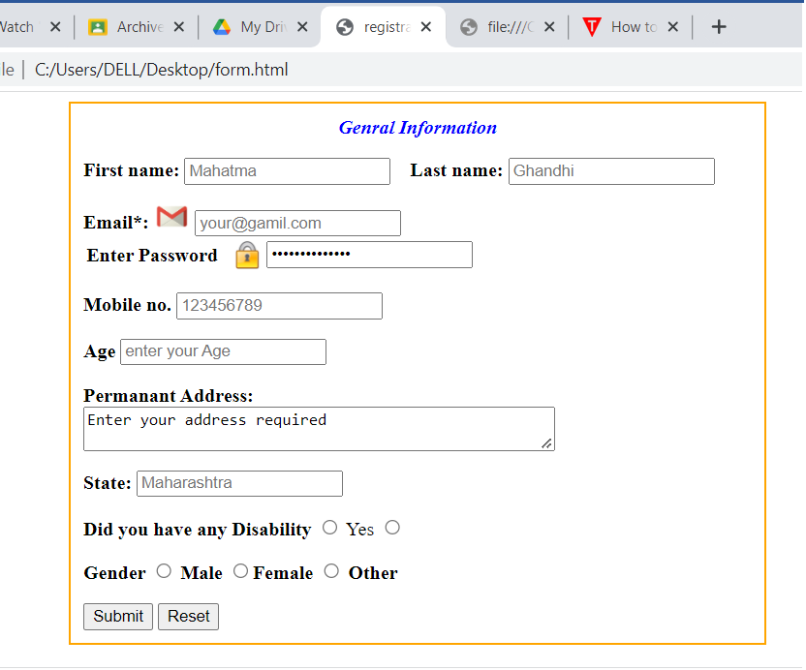

Practial 2:------------------------------------------------------------------------------------------------------------------------

<html><head>

<title>registration FORM</title>

<style>

body {padding:20px;font-size:20px;background-color:lightyellow}

</style></head>

<body>

<H1 id="ce"><i>Computer Engineering</i> </H1><table>

<p ><b>Computer engineering (CoE or CpE)</b> is a branch of electrical engineering that integrates several fields of computer science and electronic engineering required to develop computer hardware and software.[1]<i> Computer engineers</i> usually have training in electronic engineering, software design, and hardware-software integration instead of only software engineering or electronic engineering.Computer engineers are involved in many hardware and software aspects of computing, from the design of individual microcontrollers, microprocessors, personal computers, and supercomputers, to circuit design. This field of engineering not only focuses on how computer systems themselves work but also how they integrate into the larger picture.<b><i>Robots</b></i>are one of the applications of computer engineering.Usual tasks involving computer engineers include writing software and firmware for embedded

microcontrollers, designing VLSI chips, designing analog sensors, designing mixed signal circuit boards, and designing operating systems. Computer engineers are also suited for robotics research, which relies heavily on using digital systems to control and monitor electrical systems like motors, communications, and sensors.In many institutions of higher learning, computer engineering students are allowed to choose areas of in-depth

study in their junior and senior year because the full breadth of knowledge used in the design and application of

computers is beyond the scope of an undergraduate degree. </table>

<a href="https://en.wikipedia.org/wiki/Computer_engineering">

<img src="https://upload.wikimedia.org/wikipedia/commons/thumb/8/8f/Dell_Dimension_C521_Motherboard.jpg/800px-Dell_Dimension_C521_Motherboard.jpg" height="150px" width="150px"></a></p><a href="#ce"><img src="https://www.google.com/imgres?imgurl=https%3A%2F%2Fimg.freepik.com%2Ffree-vector%2Fred-start-3d-design-icon_41084-302.jpg%3Fw%3D2000&imgrefurl=https%3A%2F%2Fwww.freepik.com%2Fpremium-vector%2Fred-start-3d-design-icon_3467736.htm&tbnid=jBDlLc32E4a2TM&vet=12ahUKEwjQl-GHqeP4AhXfi9gFHYx9An4QMygOegUIARDkAQ..i&docid=wKxhrhQS2RRtBM&w=2000&h=2000&q=%22start%22&ved=2ahUKEwjQl-GHqeP4AhXfi9gFHYx9An4QMygOegUIARDkAQ">

Move to top </a></Body></html>

Output:===========================================================================

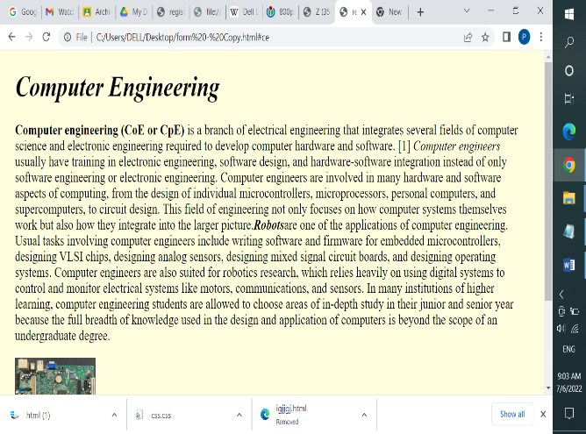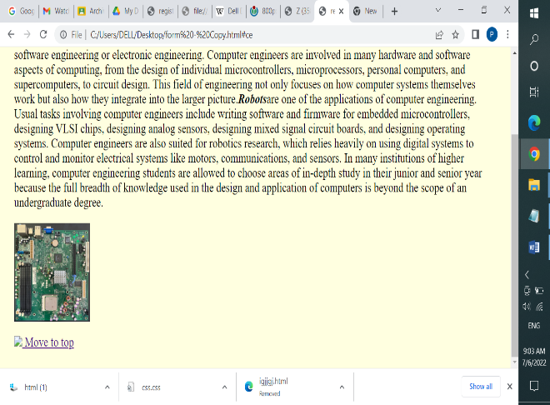

Pratical NO 3:------------------------------------------------------------------------------------------------------------------

<html><head><title> Calculator </title>

<style>

form {border:orange; border-width:2px;padding:10px; border-style:solid;}

body {padding: 0px 200px 0px 200px;}

</style></head>

<body>

<FORM name=form1 action="PAYMENT HTML"><center>

<legend style="color:blue;"><b> <i>Calculator</i></b></legend></center>

<p><b>First Number: </b><input type="text" name="a" placeholder="100"required >&nbsp&nbsp&nbsp</p><p>

<b> Last Second: </b> <input type="text" name="b" placeholder="200" required></p>

<input type="button"value="+" onclick="form1.r.value=parseInt(form1.a.value)+parseInt(form1.b.value)">

<input type="button"value="-" onclick="form1.r.value=parseInt(form1.a.value)-parseInt(form1.b.value)">

<input type="button"value="*" onclick="form1.r.value=parseInt(form1.a.value)*parseInt(form1.b.value)">

<input type="button"value="/" onclick="form1.r.value=parseInt(form1.a.value)/parseInt(form1.b.value)">

</p><p><b> Result: </b> <input type="text" name="r"placeholder="Ghandhi" required></p>

</form></Body></html>

Output:-==================================================================================

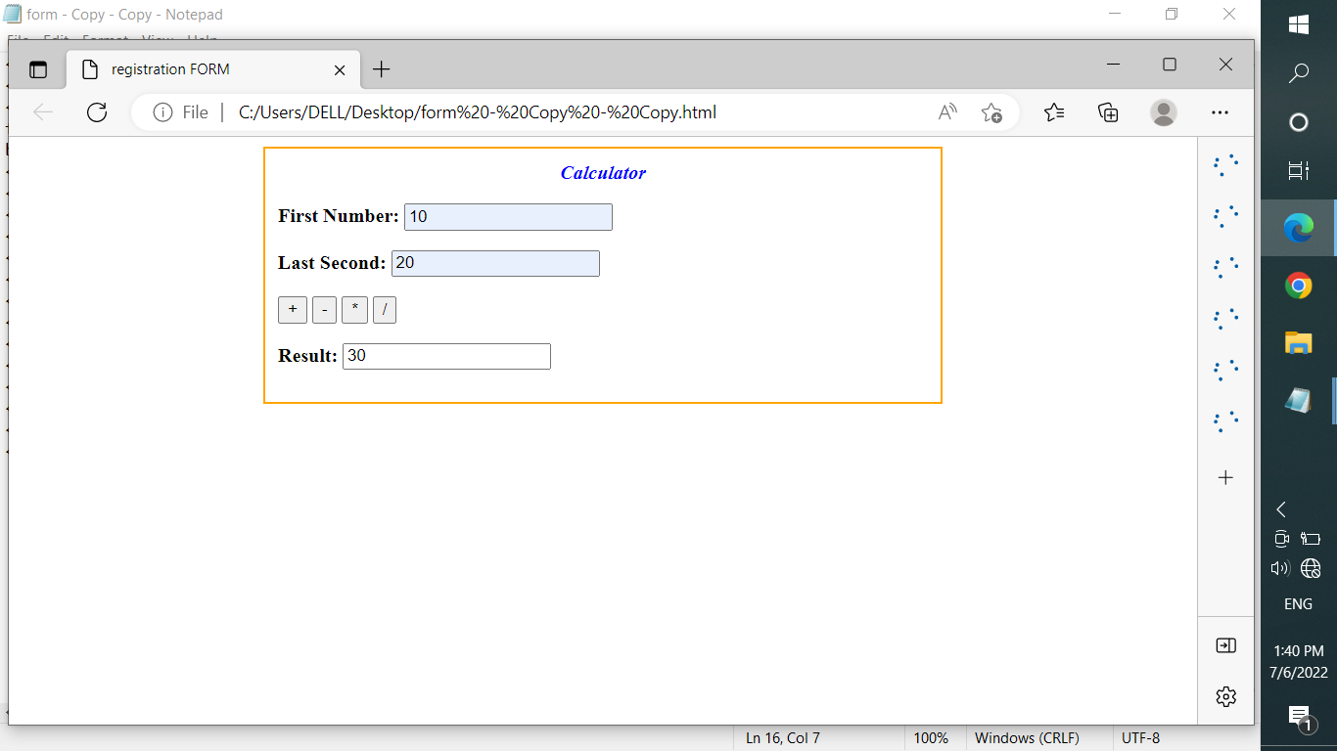

Pratical NO 4:-------------------------------------------------------------------------------------------------------------------

<html><head>

<title>registration FORM</title>

<style>

form {border:orange; border-width:2px;padding:10px; border-style:solid;}

body {padding: 0px 200px 0px 200px;}

</style>

<script>

function validate() {var email = document.getElementById("email").value; var name = document.getElementById("name").value; var number = document.getElementById("number").value;

var address = document.getElementById("add").value;

var salary = document.getElementById("salary").value;

var mailformat = /^[a-z]+[a-z0-9\.]*@[a-z]+\.[a-z]+$/;

if(email.match(mailformat)) {alert("Enter an appropriate email !");

return false; }

else if(name == "") {

alert("Enter the name correctly!"); return false;}

else if(number == "") {

alert("Enter the number correctly!"); return false;}

else if(address == "") {

alert("Enter the address correctly!"); return false; }

else if(salary == "") {

alert("Enter the salary correctly!"); return false; }

else {return true;} }

</script></head>

<body><FORM action="PAYMENT HTML" onsubmit="return validate()"><center>

<legend style="color:blue;"><b> <i>Genral Information</i></b></legend></center>

<p><b>First name: </b><input type="text" id="name" placeholder="Mahatma"required >&nbsp&nbsp&nbsp

<b> Last name: </b> <input type="text" placeholder="Ghandhi" required></p>

</table><p> <b> Email*:</b> <td><IMG SRC="http://pngimg.com/uploads/email/email_PNG11.png" HEIGHT="20PX" WIDTH="30PX" ></i></h4></td>

<td><input type="email" id="email"placeholder="your@gamil.com " required><br>

<table><td><b>Enter Password&nbsp&nbsp<b></td>

<td><IMG SRC="https://upload.wikimedia.org/wikipedia/commons/thumb/e/e1/Password.svg/1024px-Password.svg.png" HEIGHT="25PX" WIDTH="25PX"></td>

<td><input type="password" value="Enter Password"><br></td>

</table>

<p><b>Mobile no.</b> <input type="number" id="number"placeholder="123456789" required >

</p><b> Age</b> <input type="number" placeholder="enter your Age" required ><p >

<p><b>Permanant Address:</b><br><textarea id="add"required cols="50">Enter your address required</textarea></p> <p>

<p> <b> State:</b> <input type="text" name="state" placeholder="Maharashtra" required>

<p><b> Did you have any Disability</b> <input type="radio" name="section"> Yes <input type="radio" name="section">No<p><p><b> Date</b> <input type "Date"> <p>

<p><b> Gender <b><input type="radio"name="r2"> Male <input type="radio" name="r2">Female <input

type ="radio"name="r2"> Other</p>

<Button id="sl1">Submit</button>

<input type="Reset" id="sl"></input></form>

</Body>

</html>

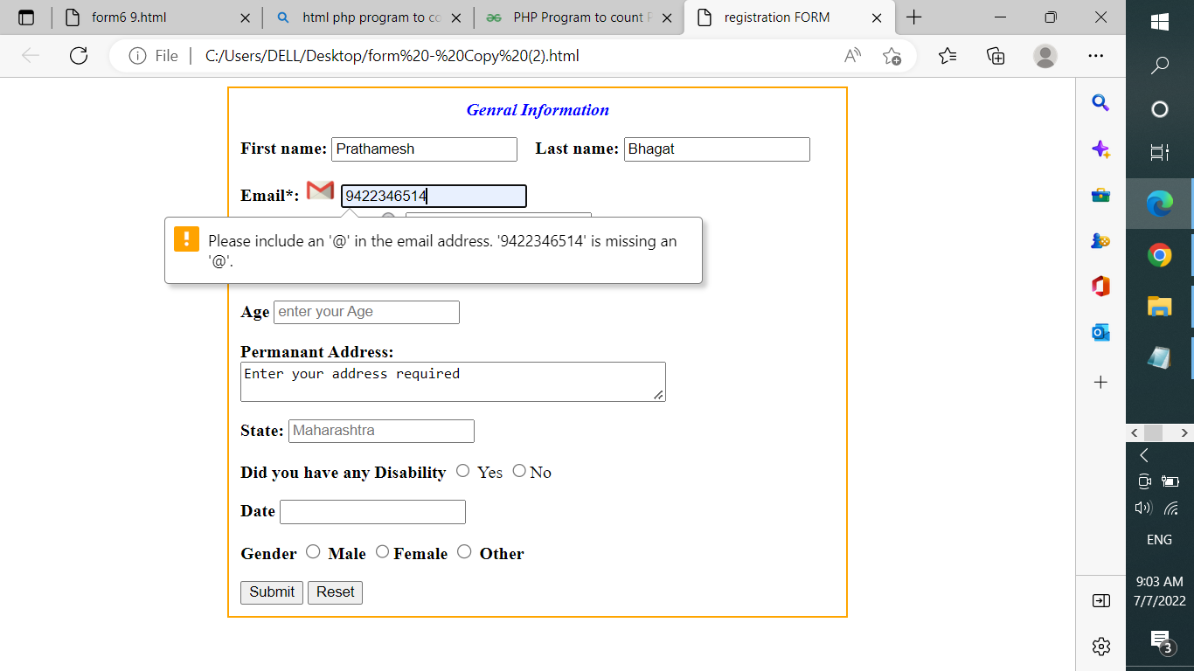

Practical NO 5-------------------------------------------------------------------------------------------------------------------

<html>

<head>

<title>Reverse the digit</title>

<style>

form {border:orange; border-width:2px;padding:10px; border-style:solid;}

body {padding: 0px 200px 0px 200px;}</style>

<script>

function aaa(){var a=parseInt(form1.a.value);

var b, sum = 0; var z = a;

while(a > 0)

{

b = a % 10;

sum = sum * 10 + b;

a = parseInt(a / 10); }

form1.r.value=sum;}

</script>

</head>

<body>

<FORM name=form1 action="PAYMENT HTML"><center>

<legend style="color:blue;"><b> <i>Reverse the Digits</i></b></legend></center>

<p><b>Enter the Number: </b><input type="text" name="a" placeholder="100"required >&nbsp&nbsp&nbsp</p><p>

<input type="button"value="Reverse" onclick="aaa()">

</p><p><b> Result: </b>

<input type="text" name="r"placeholder="Ghandhi" required></p>

</form>

</Body>

</html>

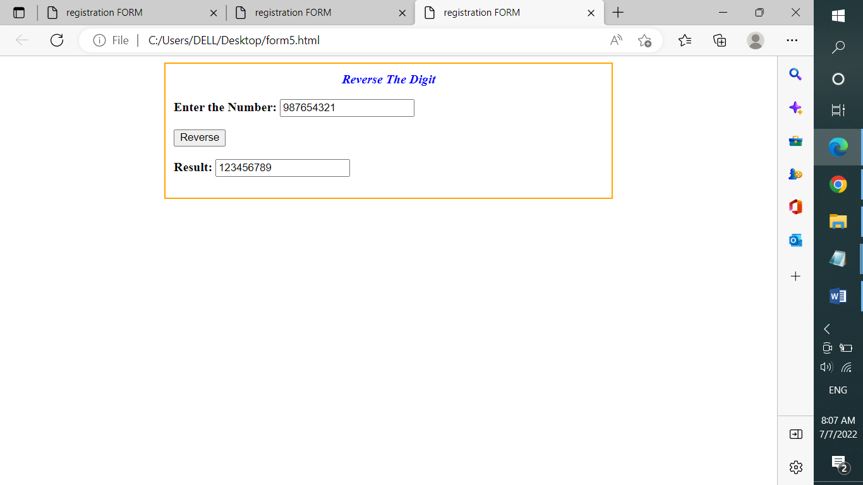

Praticle No 6---------------------------------------------------------------------------------------------------------------------

<html>

<head><title>Prime Number</title><style>

form {border:orange; border-width:2px;padding:10px; border-style:solid;}

body {padding: 0px 200px 0px 200px;}

</style><script>

function aaa(){var a=parseInt(form1.a.value);var b=parseInt(form1.b.value);

var c=""

for (i = a; i <= b; i++)

{ if (i == 1 || i == 0)

continue;

flag = 1;

for (j = 2; j <= i / 2; ++j)

{ if (i % j == 0)

{ flag = 0; break; }

} if (flag == 1) c=c+i+" "; }

form1.r.value=c;}

</script>

</head>

<body>

<FORM name=form1 action="PAYMENT HTML"><center>

<legend style="color:blue;"><b> <i>Prime Numbers</i></b></legend></center>

<p><b>Enter the Number: </b><input type="text" name="a" placeholder="100"required >&nbsp&nbsp&nbsp</p><p>

<p><b>Enter the Second Number: </b><input type="text" name="b" placeholder="100"required >&nbsp&nbsp&nbsp</p><p>

<input type="button"value="Prime" onclick="aaa()">

</p><p><b> Result: </b> <input type="text" name="r"placeholder="Ghandhi" cols="100" required></p>

</form>

</Body>

</html>

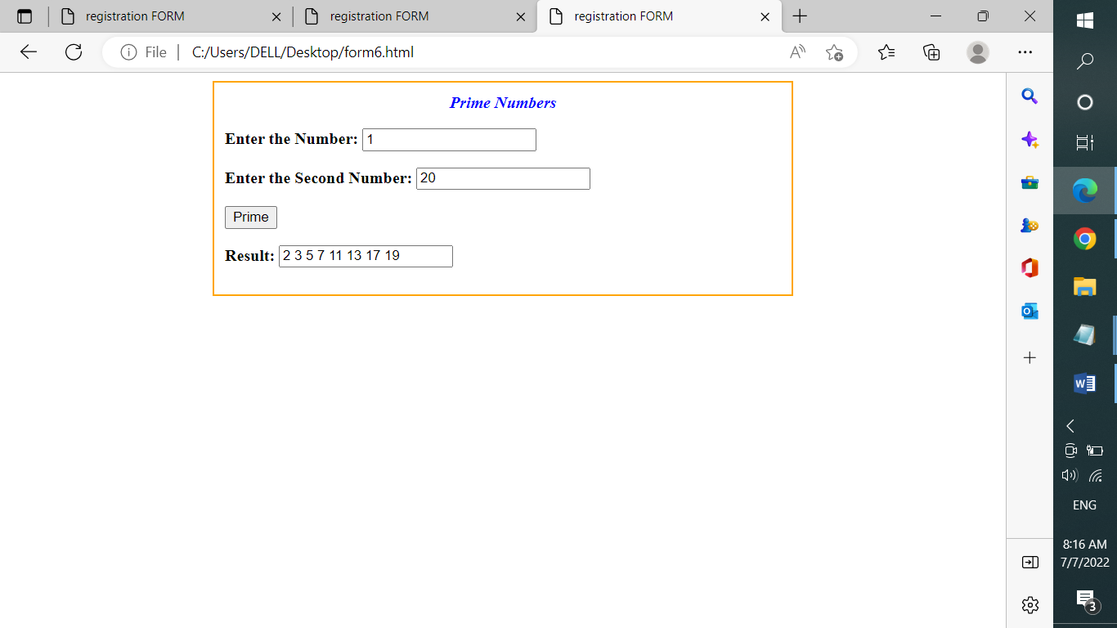

Pratical No7---------------------------------------------------------------------------------------------------------------------

<?php

$today = new DateTime("now", new DateTimeZone('Asia/Kolkata') );

echo "Todays Date is:\t\t";

echo $today->format('Y-m-d');

echo "\nThe Current Time is\t";

echo $today->format('H:i:s');

?>

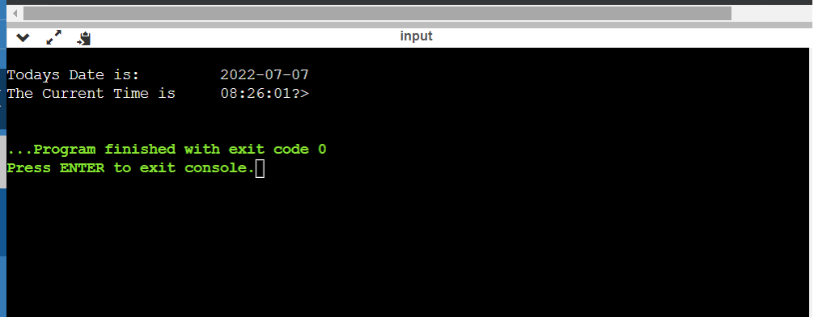

B:]

<?php

function palindrome($n){

$m = $n; $a = 0;

while(floor($m)) {

$rem = $m % 10;

$a = $a * 10 + $rem;

$m = $m/10;

}

return $a;}

echo "Enter a number\n";

$input = readline();

$num = palindrome($input);

if($input==$num)

{ echo "$input is a Palindrome ";}

else

{ echo "$input is not a Palindrome"; }

?>

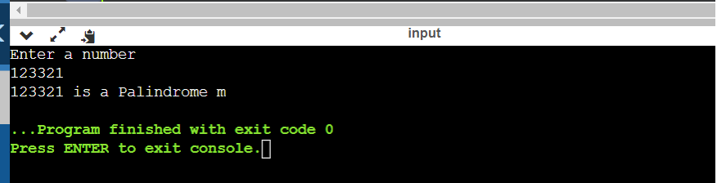

Practical No 8-------------------------------------------------------------------------------------------------------------------

<?php

echo "Enter The Percentage\n";

$i = readline();

if($i>60)

{

echo "You Recieved First Division";

}

else if($i<=59&&$i>=45)

{

echo "You Recieved Second Division";

}

else if($i<=44&&$i>=33)

{

echo "You Recieved Third Division";

}

else if($i<=32)

{

echo "You HAVE failed Please Try again";

}

?>

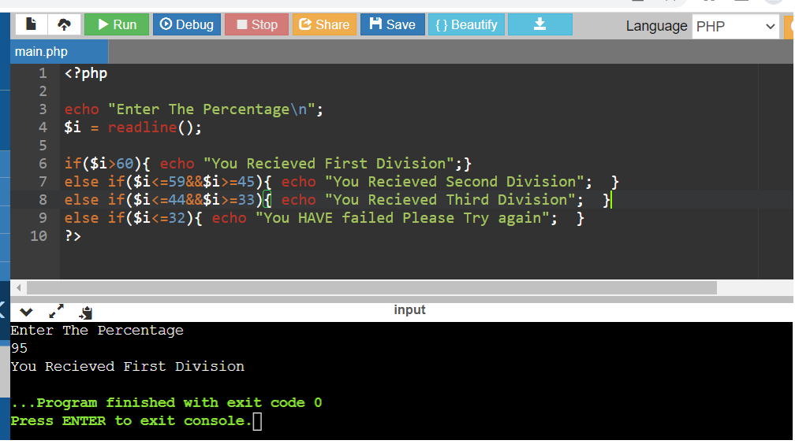

Pratical No 9---------------------------------------------------------------------------------------------------------------------

<?php

session_start();

if(isset($_SESSION['views']))

$_SESSION['views'] = $_SESSION['views']+1;

else

$_SESSION['views']=1;

echo"views = ".$_SESSION['views'];

?>.

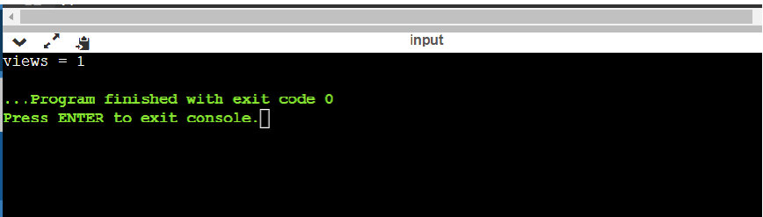

Pratical No 10-------------------------------------------------------------------------------------------------------------------

From.php:

<html><head><title>registration FORM</title><style>

form {border:orange; border-width:2px;padding:10px; border-style:solid;}

body {padding: 0px 200px 0px 200px;}</style></head>

<body>

<FORM action="conn.php" method="post"><center>

<legend style="color:blue;"><b> <i>Genral Information</i></b></legend></center>

<p><b>First name: </b><input type="text" name="firstname" placeholder="Mahatma"required >&nbsp&nbsp&nbsp<b> Last name: </b> <input type="text" name="lastname"placeholder="Ghandhi" required></p> </table>

<p> <b> Email*:</b> <td><IMG SRC="http://pngimg.com/uploads/email/email_PNG11.png" HEIGHT="20PX" WIDTH="30PX" ></i></h4></td>

<td><input type="email" name="email" placeholder="your@gamil.com " required><br>

<table><td><b>Enter Password&nbsp&nbsp<b></td>

<td><IMG SRC="https://upload.wikimedia.org/wikipedia/commons/thumb/e/e1/Password.svg/1024px-Password.svg.png" HEIGHT="25PX" WIDTH="25PX"></td>

<td><input type="password" value="Enter Password"><br></td></table>

<p><b>Mobile no.</b> <input type="number"placeholder="123456789" required >

</p><b> Age</b> <input type="number" placeholder="enter your Age" required ><p >

<p><b>Permanant Address:</b><br><textarea required cols="50">Enter your address required</textarea></p> <p><p> <b> State:</b> <input type="text" name="state" placeholder="Maharashtra" required>

<p><b> Did you have any Disability</b> <input type="radio" name="section"> Yes <input type="radio" name="section>No<p><p><b> Date</b> <input type "Date"> <p><p><b> Gender <b>

<input type="radio"name="r2"> Male <input type="radio" name="r2">Female <input

type ="radio"name="r2"> Other</p>

<Button id="sl1">Submit</button>

<input type="Reset" id="sl"></input></form>

</Body>

</html>

Conn.php:

<?php

$conn = mysqli_connect('localhost','root','','test');

$fname= $_POST["firstname"];

$lname= $_POST["lastname"];

$email = $_POST["email"];

$pwd = $_POST["pwd"];

$mob = $_POST["mob"];

$adder= $_POST["adder"];

$state = $_POST["state"];

$age = $_POST["age"];

$insert = "INSERT INTO reg(firstname,lastname,email,password,mob,adder,state,Age) VALUES('$fname','$lname','$email','$pwd','$mob','$adder','$state','$age')";

$ins = mysqli_query($conn, $insert);

if($ins)

echo "<br>inserted successfully";

?>

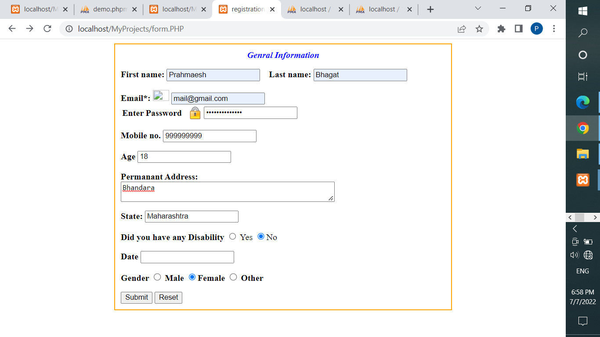

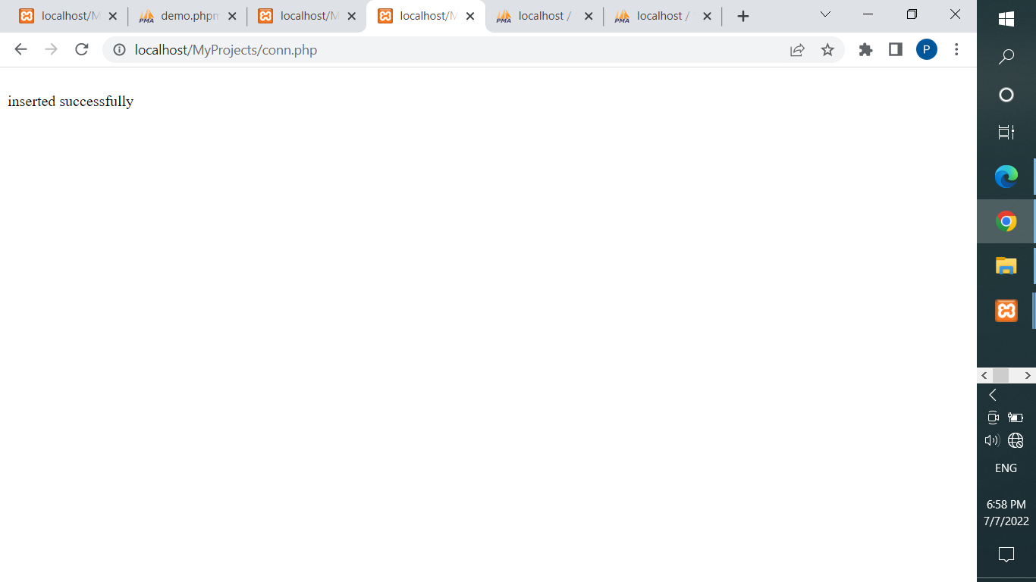

Pratical No 11-------------------------------------------------------------------------------------------------------------------

<html><head><style>

form {border:orange; border-width:2px;padding:10px; border-style:solid;}

body {padding: 0px 200px 0px 200px;}

</style></head><body>

<?php

$conn = mysqli_connect('localhost','root','','test');

$s = "SELECT * FROM reg";

$ins = mysqli_query($conn, $s);

?>

<form><table border="1px" style="width:600px;line:height:40px" >

<tr><th>First Name</th><th>Last Name</th><th>Email</th><th>Age</th>

<th>Password</th><th>Mobile No</th><th>Adderess</th><th>State</th></tr>

<?php

while($row=mysqli_fetch_assoc($ins)){?>

<tr> <td><?php echo $row['firstname']?></td><td><?php echo $row['lastname']?></td>

<td><?php echo $row['email']?></td> <td><?php echo $row['Age']?></td>

<td><?php echo $row['password']?></td><td><?php echo $row['mob']?></td>

<td><?php echo $row['adder']?></td> <td><?php echo $row['state']?></td></tr>

<?php } ?></form>

</body></html>

